SQL by APNA College

[School]

[Course title]

# History of data base

Before database people used to store data in flat files.

A flat file system is a type of file that stores a simple database representation. Because flat file databases lack linkages between tables.

**Why database was introduced?**

There were many drawbacks of flat file system, which are given below.

**Flat file system drawbacks**

* Redundancy issue means duplicate names conflict
* Security issue
* Memory issue occupying more
* Searching was difficult because of same names

# Introduction to Database

**database**

Collection of related data in a form so that I can be accessed (insert, delete,update,search) easily.

Why Databases?

* Can store large data
* Features like security, scalability etc.
* Easier to insert, update or delete data.

**DBMS (database management system)**

DBMS is a software which is used to manage the database.

**There are two types of databases**

1. Relational DB (SQL)
   1. Relational database (data stored in tables)
      1. Mysql, Oracle, PostgreSQL etc.
2. Non-rational Relational (NO SQL)
   1. Non relational databases(data stored in document/key-val/graphs etc)
      1. Mongodb, Cassandra, neo4j etc.

Data base operations:

DDL (data definition language)

DQL (data query language)

DCL (data control language)

DML (data manipulation language)

SQL(structured Query Language)

**SQL is a programming language used to interact with relational databases.**

**Table in SQL**

|  |  |  |
| --- | --- | --- |
|  | Columns |  |
| rows |  |  |
|  |  |  |

Mysql server > mysql workbench

**Schema:**

* **Database schema:** A database schema defines how data is organized within a relational database; this is inclusive of logical constraints such as, table names, fields,
* **Table schema:** design of table.

What are keys?

Keys are special columns in the table

Primary key

It is a column (or set of columns) in a table that uniquely identifies each row.(a unique id)

There is only 1 PK and it should be NOT NULL.

Foreign key

A foreign key is a column ( or set of columns) in a table that refers to the primary key in another table.

FKs can have duplicate a null values.

There can be multiple FKs.

MYSQL Commands

**Database:**

CREATE database db_name; > used to create database

CREATE DATABASE IF NOT EXISTS db_name

DROP database db_name; > used to remove database

DROP DATABASE if EXISTS db_name;

SHOW DATABASES;

SHOW TABLES;

USE db_name; > used to select database

**Create Table**

CREATE TABLE table_name(

Column_name1 datatype constraint,

Column_name2 datatype constraint,

Column_name3 datatype constraint

);

INSERT into values(101,SIRAJ,18),

(102,DUJANA,20);

Table queries:

* Create
  + CREATE TABLE table_name();
    - Data types
      * Char(50)
      * Var-char(50) optimized usage of memory
      * BLOB(used to store large Objects)
      * INT
    - Constraints(Rules for data in the table)
      * NOT NULL: columns cannot have a null value.
      * Unique: all values in column are different.
      * DEFAULT: sets the default value of a column.
      * CHECK: it can limit the values allowed in a column.
      * Ex: salary INT DEFAULT 2500 or constraint age_check check(age>=18 and city=”delhi);
      * Primary Key: makes a column unique and not null used only for one.
        + Ex: create table temp ( id int, primary key(id));
        + Ex: create table temp( id int primary)
      * Foreign key: prevent actions that would destroy links between tables.
      * We can connect tables through it.
      * Primary key of another table in the table will be foreign key.

Student table

|  |  |  |
| --- | --- | --- |
| Id | Name | T-id(foreign key) |
| 101 | siraj | 1 |

Teacher table

|  |  |
| --- | --- |
| Id(primary key) | name |
| 1 | dujana |

Foreign key (t-id) references teacher (id)

* + - * + Ex: create table temp( cust_id int, foreign key (cust_id) references customer(id)
* Insert
  + INSERT INTO VALUES();
* Update
* Alter
* Truncate
* delete

**Select Command**

Selects and show data from the DB

Syntax:

Select column1, column 2 FROM table_name;

Select * FROM table_name;

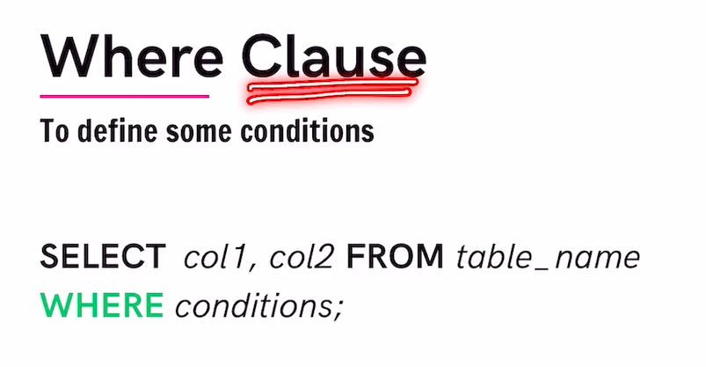

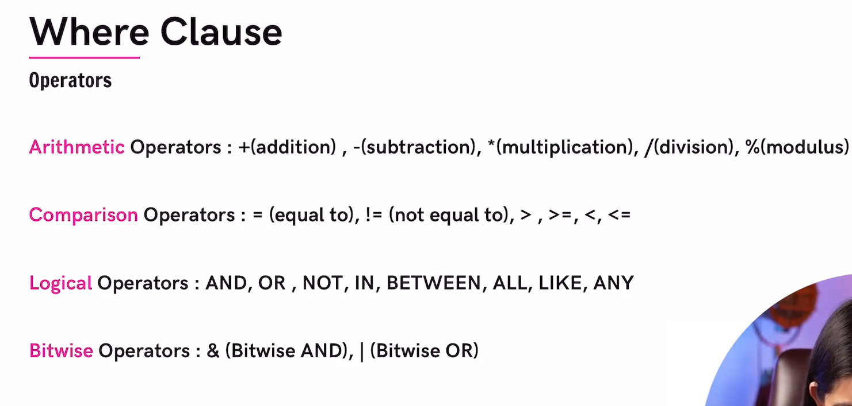

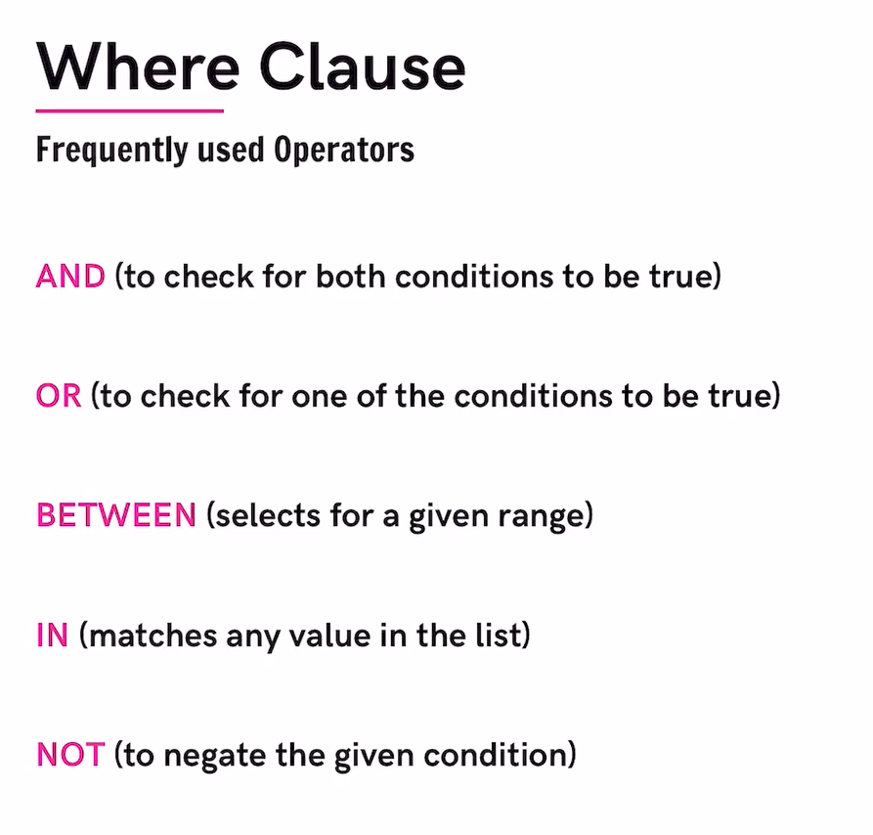

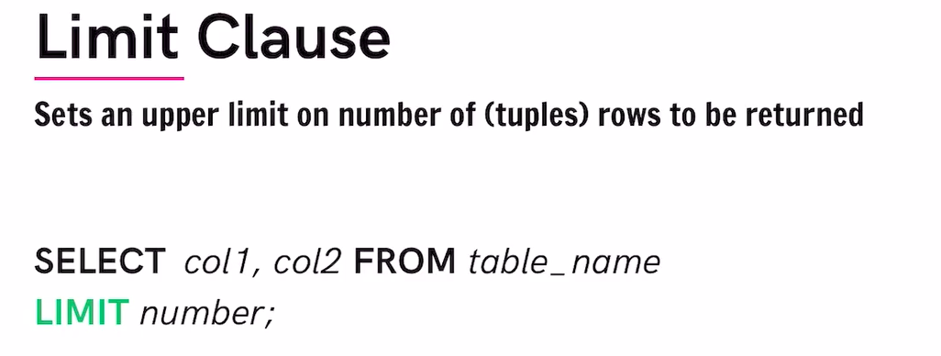

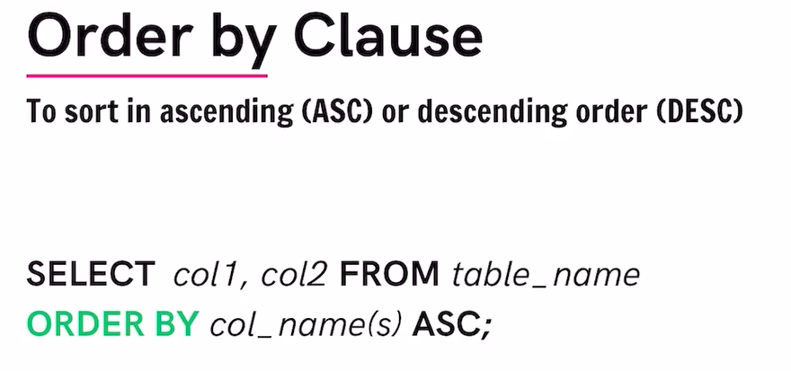

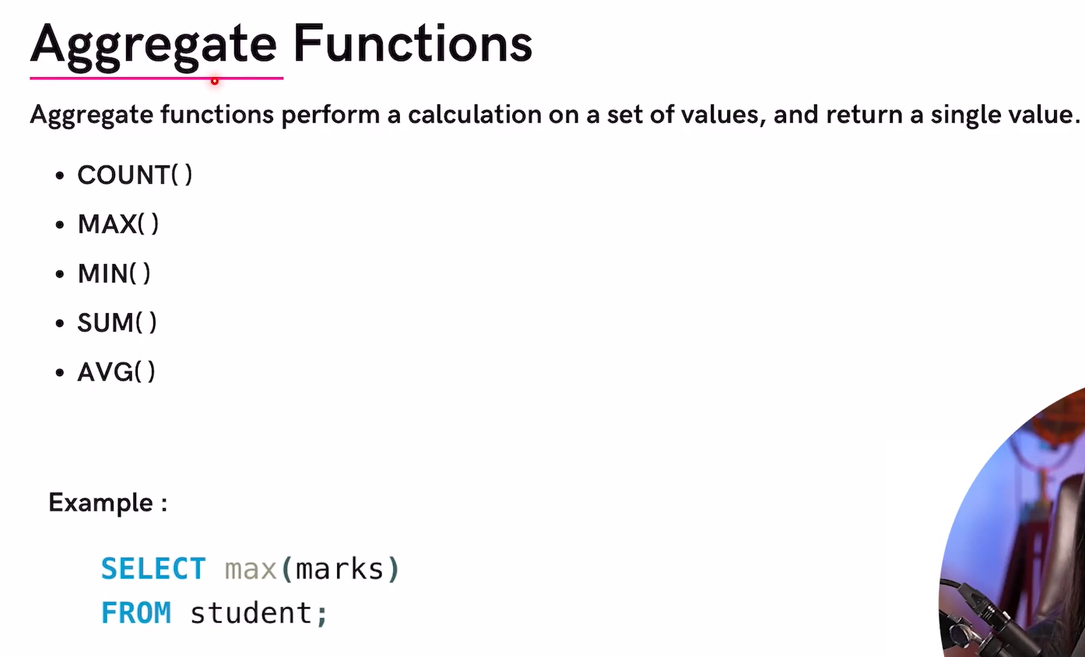

**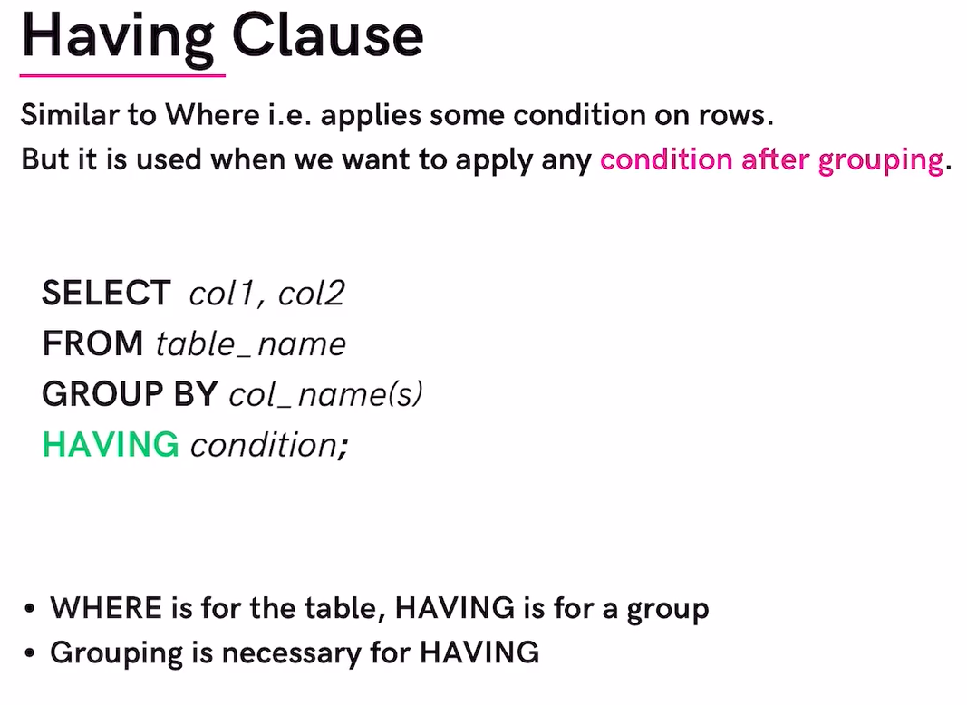  
  
  
  
  
  
  
  
  
  
  
  
  
  
  
  
  
  
  
  
  
  
  
  
  
  
  
  
  
  
  
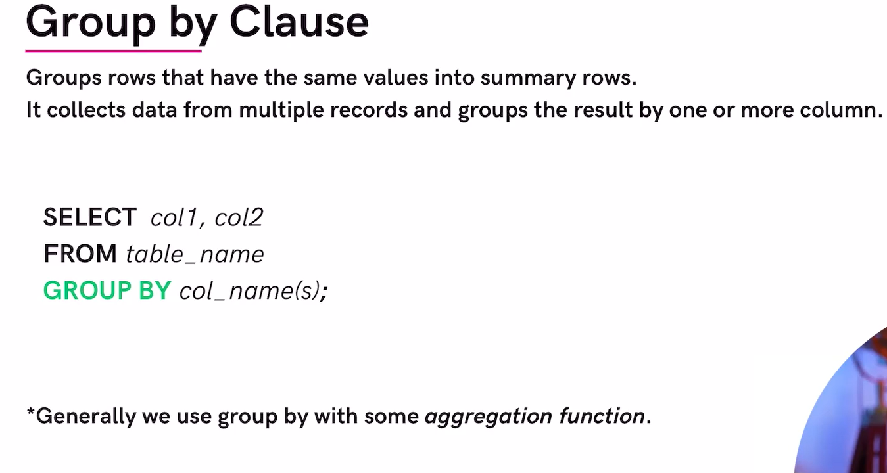**

**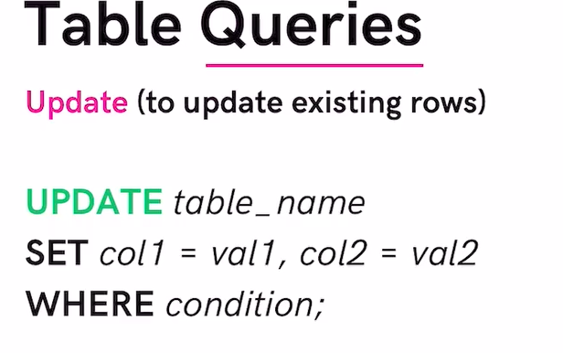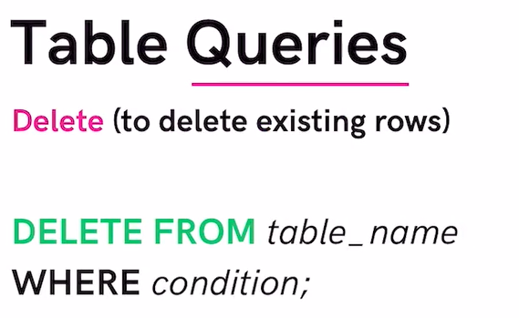  
  
  
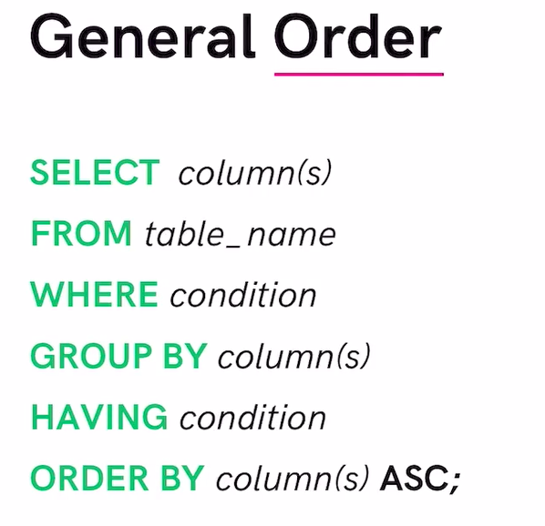**

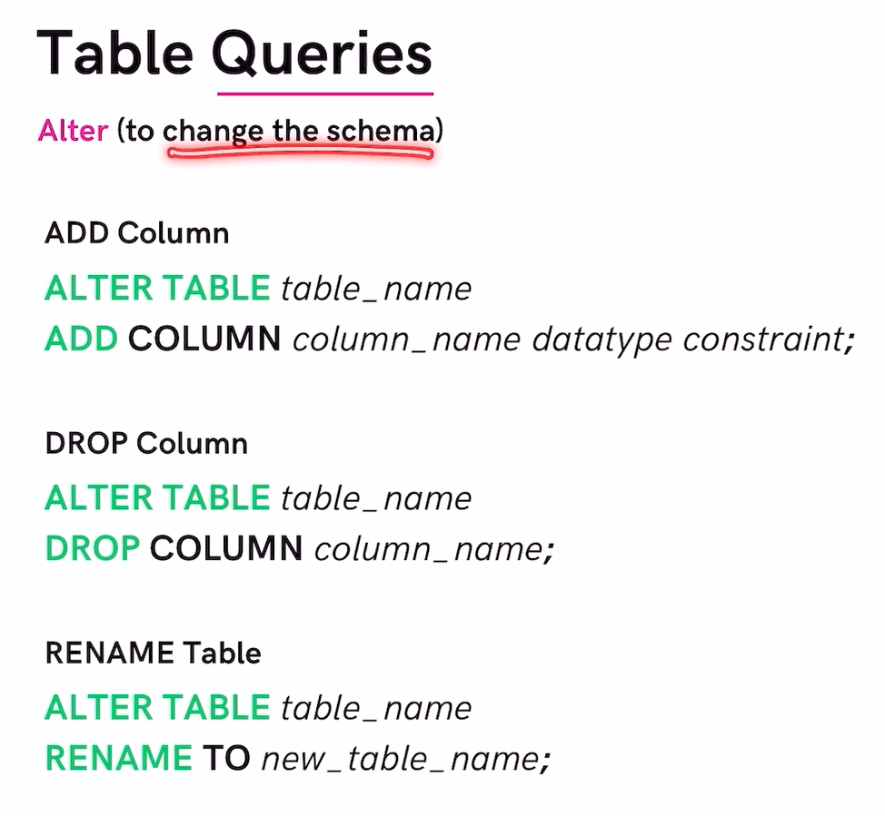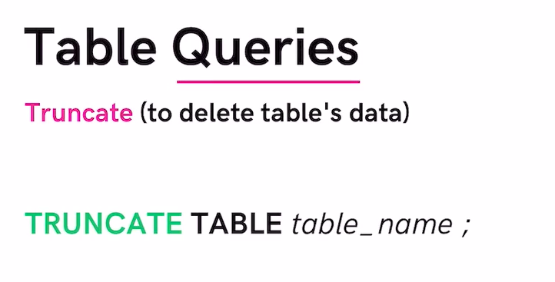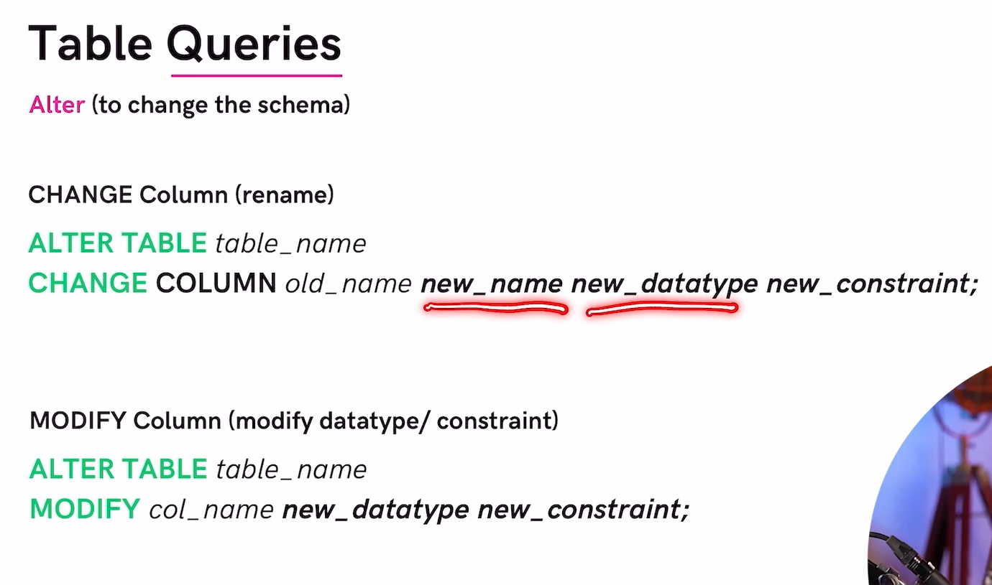

**table sample:**

**CREATE TABLE user(**

**Id int,**

**Age int,**

**Name varchar(30) not null,**

**Email varchar(50) unique,**

**Followers int default 0,**

**Following int,**

**Constraint check (age>=13)**

**);**

**Create table post(**

**Id int primary key,**

**Content varchar(100),**

**User_id int,**

**Foreign key (user_id) references user(id)**

**);**

**Entity relationship diagram**